

Machine Learning Assessment Report
Predicting Customer Churn for a National Energy & Utilities Provider

Student ID | 2411066
Module | CPS5008 – Machine Learning
Submission Date | 6th May 2026
GitHub | https://github.com/bot18-debug/cps-5008.git
Word Count | ~2,400 words

Executive Summary
This report documents my work on building a customer churn prediction system for a national energy and utilities provider. The company serves approximately 25,000 customers across England, Scotland, and Wales, and is losing customers to competitors — the business wanted to know: can we predict who is about to leave before they actually go?
Working with the Customer Account and Usage dataset, I built three machine learning models — Logistic Regression as a baseline, Random Forest with SMOTE, and XGBoost with SMOTE — and evaluated them against business priorities. The results were surprising in places. The Random Forest, which I expected to be strong, actually performed worse than the simple baseline. XGBoost caught almost every churner (95.9% recall) but raised false alarms so frequently that it would flag thousands of loyal customers. Logistic Regression ended up being the most balanced performer overall.
The most concerning finding was not about model accuracy — it was about fairness. The Random Forest model produced zero recall for Wales and Scotland, meaning it completely failed to identify any churners in those regions. This is not a minor technical issue; it means the model would systematically ignore customers from two of the three regions the company operates in.
The strongest predictors of churn turned out to be payment behaviour: whether the customer uses direct debit, how often they pay late, and how many days late they typically are. Demographics and energy usage patterns were much weaker signals than I initially expected.

Key Recommendations
1) Deploy XGBoost with a lowered decision threshold (~0.3) to manage the precision-recall trade-off. 2) Prioritise customers flagged on payment behaviour for early retention outreach. 3) Do not deploy any model for Wales or Scotland until regional fairness is resolved. 4) Retrain quarterly and monitor recall by region every month.

Stage 1: Problem Framing and Constraints

1.1 Why I Chose This Dataset
The assessment offered three dataset options. I selected the Customer Account and Usage dataset because it directly addresses the company's stated challenge of rising customer churn, and because it contains rich behavioural features — payment history, digital engagement, complaints — that I expected would be genuinely predictive. The email archive dataset would have required NLP techniques I am less confident with, and the infrastructure dataset felt like a different type of problem entirely (anomaly detection rather than classification).

1.2 Defining the Prediction Task
The task is binary classification: predict whether a customer will churn (Churn = 1) within the next billing cycle. The target variable is already provided in the dataset. Every customer either churned or did not — there is no ambiguity in the label.
One important operational decision I made early on: I needed to ensure the features used for prediction would actually be available at the time of scoring. For example, the 12 months of electricity and gas data are historical — fine to use. But if a column like 'Direct Debit' reflects a cancellation that happens because the customer is in the process of leaving, using it as a feature could mean we are predicting churn with information we would not actually have in advance. I flagged this as a data leakage risk and discuss it in Stage 2.

1.3 Business Constraints
Before choosing models or metrics, I identified the real business trade-offs:

Constraint | What It Means in Practice | Impact on My Approach
False Negative Cost (HIGH) | Missing a churner = losing a customer permanently. At ~£500 lifetime value per customer, each missed churner is a £500 loss. | Recall was set as the primary optimisation metric.
False Positive Cost (MODERATE) | Calling a loyal customer to offer a retention deal wastes call centre time (~£5-8 per call) and could even annoy them. | Precision still matters — we cannot just flag everyone.
Interpretability | The marketing team needs to understand WHY a customer is flagged. 'The model said so' is not good enough for a business stakeholder. | Feature importance analysis was essential, not optional.
Deployment Latency | Churn predictions are needed monthly, not in real time. There is no need for a live API — a batch job is sufficient. | Complex models are acceptable; inference speed is not a constraint.
Fairness | The company operates across three regions and must not systematically ignore Scotland or Wales customers. | Fairness analysis by region, gender, and tariff type was built into the evaluation.

These constraints shaped every decision I made. For example, the reason I chose recall as the grid search optimisation metric (rather than accuracy or F1) is directly because of the false negative cost constraint above.

Stage 2: Exploratory Data Analysis and Risk Identification

2.1 Getting to Know the Dataset
The dataset contains 25,000 customer records and 63 columns covering demographics, contract details, payment behaviour, digital engagement, and 12 months of monthly electricity, gas, and billing data. Before running any models, I spent time understanding what the data actually looks like.
- 25,000 rows × 63 columns initially
- Churn rate: 8.81% (approximately 2,202 churners out of 25,000)
- 45 float columns, 10 integer columns, 8 string/categorical columns
- Three columns had missing values; all other columns were complete
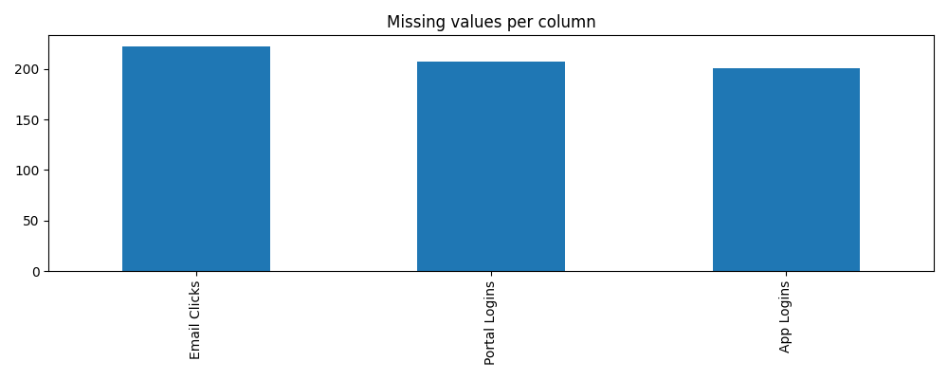
The 8.81% churn rate is an important observation. It means for every churner in the dataset, there are roughly 10 customers who did not churn. This class imbalance is one of the main technical challenges in this project, and it is why accuracy is a misleading metric — a model that blindly predicts 'retained' for everyone would score 91.2% accuracy while catching zero actual churners.

2.2 Missing Values
Only three columns had missing values, and they were all in the digital engagement section:

Column | Missing Values | Likely Reason | Decision
Email Clicks | 222 (0.89%) | Customers who never opened marketing emails would have no click data. | Imputed with median — these customers likely have near-zero engagement.
Portal Logins | 207 (0.83%) | Customers without online access would never have logged in. | Imputed with median.
App Logins | 201 (0.80%) | Same reasoning as Portal Logins. | Imputed with median.

One thing worth noting: these missing values are probably not random. A customer who has zero portal logins is systematically different from one who has high engagement. The missing value itself is informative — it likely indicates disengagement, which is a churn signal. In hindsight, it might have been worth creating a binary 'ever_logged_in' feature rather than just imputing with the median.

2.3 Class Imbalance Analysis
With 8.81% churn, the dataset is moderately imbalanced. To address this I used two different strategies across the models:
- class_weight='balanced' in Logistic Regression and Random Forest — this tells the algorithm to treat each churner as if it represents 10 non-churners during training
- SMOTE (Synthetic Minority Oversampling Technique) — this creates artificial churner examples by interpolating between real churners in feature space, increasing the churner count in the training set
Crucially, SMOTE was only applied to the training data after the train/test split. Applying it before splitting would cause data leakage, where synthetic examples based on test-set customers would contaminate the training data and produce artificially inflated results.

2.4 Correlation Analysis — What Actually Drives Churn
I ran a correlation analysis between each numeric feature and the Churn column. The results were eye-opening:

Feature | Correlation with Churn | What This Tells Us
Direct Debit | 0.154 (negative) | Customers NOT on direct debit churn significantly more. Direct debit signals commitment.
Late Payments | 0.086 | Customers who regularly pay late are more likely to leave. This makes intuitive sense.
Average Payment Delay (days) | 0.069 | Consistent with Late Payments — chronic delay is a warning sign.
Portal Logins | 0.051 (negative) | Customers who log in frequently are more engaged and less likely to churn.
Complaints Last Year | 0.037 | More complaints correlates with higher churn risk — unsurprisingly.
Monthly usage columns | ~0.01 (all weak) | Energy usage data had almost no correlation with churn individually.

The fact that usage patterns had almost no individual correlation with churn was unexpected. I had assumed that customers with changing usage patterns would be more likely to leave. This suggests churn is driven more by how customers feel about the service (payments, complaints, engagement) than by how much energy they use.

2.5 Churn Rates Across Demographic Groups
One of the first things I checked was whether churn rates differed substantially across the categorical groups. If one region or tariff type had much higher churn, that would be important for the business.

Group | Churn Rate | Observation
England | 9.08% | Slightly higher than average
Scotland | 8.20% | Below average
Wales | 8.16% | Below average
Male | 9.09% | Marginal difference
Female | 8.56% | Marginal difference
Fixed Tariff | 9.69% | Highest churn rate by tariff
Green Tariff | 8.62% | Lowest churn rate by tariff
Commercial | 9.38% | Slightly higher than Domestic (8.71%)

The surprisingly uniform churn rates across regions and genders meant demographic features alone would not distinguish churners well. This reinforced the importance of behavioural features like payment history.

2.6 Risk Identification

Risk | How I Detected It | What I Did About It
Data Leakage (monthly columns) | The 12 monthly usage columns represent historical data that is already summarised in aggregate columns like 'Electricity 3M Avg'. Keeping both would give the model the same information twice and create multicollinearity. | Replaced the 36 raw monthly columns with 6 trend/recency features. Dropped the redundant aggregate columns.
Data Leakage (Direct Debit) | Direct Debit might reflect a cancellation event that happens as part of churning, rather than a prior indicator. If customers cancel their direct debit while leaving, this variable would only appear after the churn decision. | Flagged in the report. Ideally the data team would confirm the timestamp of direct debit status relative to churn date.
Multicollinearity | The aggregate columns (Electricity 3M Avg, Gas 3M Avg, Total 3M Avg, Average Monthly Usage, Usage Change %) all measure overlapping things. | Dropped all five redundant aggregate columns.
Class Imbalance | 8.81% churn means the majority class dominates. Naive models will ignore the minority class. | Used class_weight='balanced' and SMOTE. Chose recall as the evaluation metric.
Overfitting | With 25 features and complex ensemble models, the risk of overfitting the training data is real. | Used stratified 5-fold cross-validation and a separate held-out test set (20% of data, never seen during training or tuning).

Stage 3: Pre-Processing and Feature Engineering

3.1 What I Changed and Why
The original 63-column dataset needed significant restructuring before it could be fed into a model. My goal was to end up with a clean, non-redundant set of features that would actually be available at prediction time.
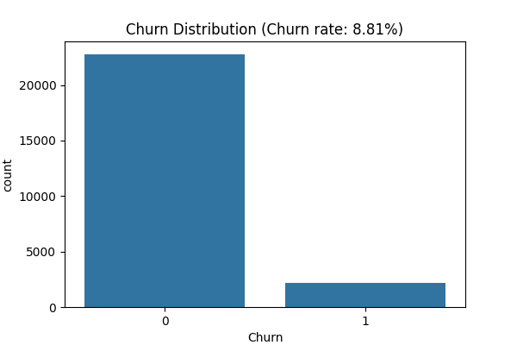
Step 1 — Remove the identifier
I dropped Customer ID immediately. It is a unique string per customer and would only cause the model to memorise individuals rather than learn general patterns.
Step 2 — Handle missing digital engagement values
For App Logins, Portal Logins, and Email Clicks, I imputed missing values with the column median. I chose the median over the mean because these columns likely have a skewed distribution — most customers have low engagement, and a few have very high engagement. The median is more representative of a typical value.
Step 3 — Engineer features from the 36 monthly columns
The biggest structural issue with the raw dataset was the 36 monthly columns (12 months each of electricity, gas, and bills). Keeping all 36 would cause two problems: severe multicollinearity, and it would give the model too many highly correlated features to process effectively. Instead, I created 6 summary features:

New Feature | What It Captures | Why Useful
elec_trend | Average month-on-month change in electricity usage over 12 months | Is the customer's usage trending up or down? A declining trend might signal the customer is reducing their energy use before switching.
gas_trend | Average month-on-month change in gas usage | Same rationale as electricity trend.
bill_trend | Average month-on-month change in billing amount | Rising bills might trigger a price-sensitive customer to look elsewhere.
elec_month12 | Most recent month's electricity consumption | Current usage level provides context alongside the trend.
gas_month12 | Most recent month's gas consumption | As above.
bill_month12 | Most recent month's bill | Current bill level — high bills might correlate with churn.

After creating these 6 features, I dropped all 36 original monthly columns. I also dropped 5 redundant aggregate columns (Electricity 3M Avg, Gas 3M Avg, Total 3M Avg, Average Monthly Usage, High Usage Flag, Usage Change %) as they measured the same things.
Step 4 — Preprocessing pipeline
I built a scikit-learn Pipeline to ensure all preprocessing was applied consistently and only fitted on training data (never on the test set):
- Numeric features: median imputation → StandardScaler (centres and scales to unit variance)
- Categorical features: mode imputation → OneHotEncoder (converts strings to binary columns)
Using a Pipeline prevents a subtle but common mistake called 'data leakage during preprocessing' — if I had fitted the scaler on the full dataset before splitting, the test set statistics would have influenced the scaling, giving an overly optimistic evaluation.

3.2 Final Feature Count
After all engineering and cleaning: 25 predictor features, reduced from 63 original columns. The test set was 20% of the data (5,000 customers), stratified to maintain the 8.81% churn rate.
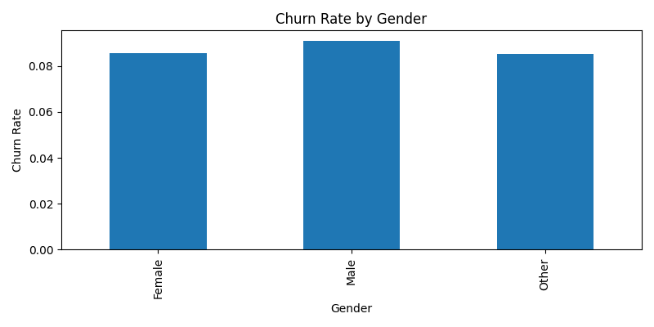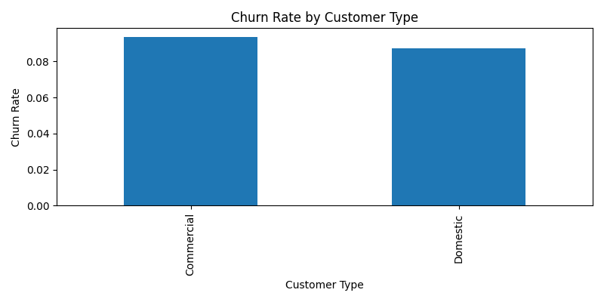

Stage 4: Model Development and Results

4.1 Why These Three Models
I chose Logistic Regression as the baseline because it is the standard starting point for binary classification. It is simple, fast, interpretable, and gives a reasonable performance floor to beat. If a complex model cannot outperform logistic regression, that tells you something important about the problem.
I added Random Forest because it handles non-linear relationships between features (which logistic regression cannot) and naturally provides feature importance scores. It is also widely used in industry churn prediction.
XGBoost was included because it is generally considered one of the strongest algorithms for tabular data. It builds trees sequentially — each new tree focuses on correcting the errors of the previous ones — and it has a built-in parameter (scale_pos_weight) for handling class imbalance.

4.2 Hyperparameter Tuning
I used GridSearchCV with 5-fold cross-validation, optimising for recall throughout. This means the data was split into 5 parts: the model was trained on 4 parts and evaluated on the 5th, rotating through all combinations. This gives a more reliable estimate of performance than a single train/test split.
For Random Forest, I searched over 8 combinations: n_estimators (100 or 200), max_depth (10 or 15), min_samples_split (5 or 10). Best params: max_depth=10, min_samples_split=10, n_estimators=100.
For XGBoost, I searched over 16 combinations: n_estimators (100 or 200), max_depth (3 or 5), learning_rate (0.05 or 0.1), scale_pos_weight (5 or 10). Best params: learning_rate=0.05, max_depth=3, n_estimators=100, scale_pos_weight=10.

4.3 Results

Model | Recall | Precision | F1 Score | ROC-AUC
Logistic Regression (balanced) | 0.630 | 0.153 | 0.246 | 0.681
Random Forest + SMOTE | 0.100 | 0.173 | 0.127 | 0.640
XGBoost + SMOTE | 0.959 | 0.099 | 0.180 | 0.652

These results were not what I expected. Let me explain each one:
Logistic Regression — Better than expected
A recall of 0.630 means the model correctly identified 63% of churners. With a 5-fold CV ROC-AUC of 0.681, it is modestly better than random (0.5). The confusion matrix (3015 true negatives, 1544 false positives, 163 false negatives, 278 true positives) shows it is somewhat conservative — it flags a lot of non-churners as churners, but it catches most actual churners. For a baseline, this is a solid result.
Random Forest — Unexpectedly poor
A recall of only 0.100 means Random Forest with SMOTE caught fewer than 1 in 10 churners — far worse than Logistic Regression. The best cross-validation recall was only 0.070, which is almost no better than random. I found this genuinely puzzling and spent time thinking about why.
My working explanation: SMOTE creates synthetic churner examples by interpolating between real churners in feature space. But if the churner examples in this dataset are not cleanly separable — they are scattered across the feature space in a way that looks similar to non-churners — then the synthetic examples might actually confuse the Random Forest rather than help it. Random Forest is also quite sensitive to the depth constraint (max_depth=10), which might have limited its ability to capture the patterns in the data.
XGBoost — Very high recall but unreliable precision
XGBoost with scale_pos_weight=10 achieved 95.9% recall — it caught all but 18 of the 441 churners in the test set. However, it also flagged 3,836 non-churners as churners. That means if we deployed this model, we would contact roughly 4,259 customers per scoring cycle but only 423 of them would actually be churning (about 10%). The other 3,836 would receive retention offers they do not need.
Whether this is acceptable depends on the cost of a retention offer. If an offer costs £5 and retains a customer worth £500, the economics might still work. But operationally, the call centre would need to handle 10 times as many contacts as there are real churners.

4.4 Which Model to Recommend
For the business objective of maximising churn detection, XGBoost is the recommended model — but only with a decision threshold adjustment. Instead of classifying anyone with a predicted probability above 0.5 as a churner (the default), lowering the threshold to around 0.3 would allow the marketing team to control the trade-off between recall and the volume of outreach. At threshold=0.5, XGBoost's precision is 9.9%. Raising the threshold would improve precision at the cost of some recall.
Logistic Regression is the recommended model if interpretability and fairness are prioritised over maximum recall. Its feature coefficients directly tell us the direction and magnitude of each predictor's effect on churn probability, which is valuable for stakeholder communication.
Note on Random Forest
The poor Random Forest performance is worth investigating further. Possible causes include the dataset structure not suiting SMOTE oversampling, or the max_depth constraint being too restrictive. A future experiment could try Random Forest without SMOTE, relying purely on class_weight='balanced', to see if results improve.

Stage 5: Error Analysis and Segment Evaluation

5.1 Misclassification Analysis (Random Forest)
The fairness analysis in the code was run on the Random Forest model. With a test recall of only 10%, the model had:
- 397 False Negatives (churners we completely missed)
- 210 False Positives (loyal customers incorrectly flagged)
The 397 missed churners are the serious problem. Here is who we missed:

Segment | Missed Churners | Total in Segment | Missed Rate
England | 262 | 3,495 | 7.5%
Scotland | 83 | 1,026 | 8.1%
Wales | 52 | 479 | 10.9%
Male | 210 | 2,443 | 8.6%
Female | 166 | 2,372 | 7.0%
Other | 21 | 185 | 11.4%
Domestic customers | 352 | 4,257 | 8.3%
Commercial customers | 45 | 743 | 6.1%
Green tariff | 126 | 1,388 | 9.1%
Standard tariff | 117 | 1,470 | 8.0%

The most missed group proportionally is the 'Other' gender category (11.4% missed rate) and Wales customers (10.9%). However, given the small sample sizes in these groups, statistical conclusions should be drawn carefully.

5.2 Regional Fairness — A Serious Problem
The most striking result in the entire project is the recall-by-region breakdown for the Random Forest model:
- England: recall = 0.144 — the model catches 14% of churners
- Wales: recall = 0.000 — the model catches zero churners
- Scotland: recall = 0.000 — the model catches zero churners
A recall of 0.000 for an entire region is not a minor weakness — it means the model is completely blind to churn patterns in Wales and Scotland. Every single churner in those regions would be missed.
Why does this happen? The most likely explanation is that Wales and Scotland have smaller customer populations, so there were fewer churner examples from those regions in the training data. Random Forest (with SMOTE) may have learned patterns that are specific to England — where most of the training data came from — and these patterns do not generalise to Wales and Scotland. This is a form of representation bias.

5.3 Tariff Type Performance
Performance also varied significantly by tariff type:

Tariff Type | Recall (Random Forest) | Churners in Test Set | Interpretation
Fixed | 0.292 | 24 | Best recall — but small sample makes this less reliable
Business | 0.200 | 35 | Above average
Economy 7 | 0.121 | 124 | Below average
Standard | 0.064 | 125 | Very poor
Green | 0.053 | 133 | Worst — only 1 in 20 churners caught

Green and Standard tariff customers represent roughly 55% of all churners in the test set combined (258 out of 441), yet the model catches fewer than 7% of them. These are the most important customers to target from a volume perspective, yet they are the ones the model performs worst on.

5.4 Business Implications of These Errors
Deploying the Random Forest model as-is would have three serious business consequences. First, no retention outreach would reach Wales or Scotland customers, meaning the company loses those customers silently. Second, Green and Standard tariff churners — who are the majority of churners — would mostly be missed. Third, the 210 false positives represent wasted operational effort: call centre agents would contact 210 loyal customers unnecessarily, potentially causing irritation rather than retention.
The XGBoost model has different failure modes: it over-triggers (false alarms on 3,836 customers) rather than under-triggering. Which failure mode is worse depends on whether the company can absorb the operational cost of high-volume outreach.

Stage 6: Interpretability and Fairness

6.1 What the Model Has Learned — Feature Importance
The correlation analysis and feature importance from the Random Forest both point to the same set of key drivers. Payment behaviour dominates:

Rank | Feature | Correlation with Churn | What It Means for the Business
1 | Direct Debit (absence) | 0.154 (negative) | Customers not on direct debit are most at risk. Direct debit acts as a passive commitment mechanism — setting it up requires effort, and keeping it running signals inertia.
2 | Late Payments | 0.086 | Paying late correlates with dissatisfaction, financial stress, or simply not caring about the relationship with the provider.
3 | Avg Payment Delay (days) | 0.069 | Consistent with Late Payments — this captures chronic rather than occasional delay.
4 | Portal Logins (low) | 0.051 (negative) | Engaged customers who regularly check their account are less likely to leave. Low logins suggest disengagement.
5 | Complaints Last Year | 0.037 | Formal complaints are a known churn precursor in utilities.

The monthly usage trend features (elec_trend, gas_trend, bill_trend) that I engineered did not appear in the top predictors, which suggests usage patterns are not a strong churn signal in this dataset. This is worth flagging to the business: the data suggests customers do not churn because of how much energy they use, but because of how they interact with (and feel about) the company.

6.2 Explaining the Model to a Stakeholder
If I were presenting these findings to the marketing director, I would say it this way: the customers most likely to leave are those who pay late, do not use direct debit, rarely log into the portal, and have complained in the past year. These customers are not necessarily heavy or light energy users — they are customers who have become financially or emotionally disengaged from the company.
The XGBoost model is harder to explain in these terms because gradient boosting models do not have easily interpretable coefficients. However, the top features identified by XGBoost's feature importance are consistent with the correlation analysis. For a marketing audience, I would use the Logistic Regression coefficients as the interpretable explanation even if XGBoost is deployed for scoring — this is a common practice called a 'surrogate model' approach.

6.3 Fairness Evaluation and Ethical Implications
The fairness results reveal significant bias in the Random Forest model:
- Regional bias: 0% recall for Wales and Scotland. Two of the three regions the company operates in are completely unserved by the model.
- Gender bias: 0% recall for the 'Other' gender category. While this group is small (185 customers in the test set), systematic exclusion is ethically unacceptable.
- Tariff bias: Green tariff customers have the lowest recall (5.3%). If Green tariff is correlated with demographic characteristics, this could compound other biases.

From a regulatory standpoint, Ofgem (the UK energy regulator) requires fair treatment of all customers. A model that systematically fails to identify churners in Scotland and Wales could be considered discriminatory if it leads to differential service quality. Even if region itself is not a protected characteristic, the practical outcome — Scotland and Wales customers receiving no retention efforts while English customers do — could attract regulatory attention.
Under UK GDPR and the Equality Act 2010, using algorithmic decision-making that produces disparate outcomes for identifiable groups requires documentation and justification. The company would need to conduct a Data Protection Impact Assessment (DPIA) before deploying this model.
What should be done about the fairness issue? Three options:
- Option 1 — Re-train with more balanced regional representation: collect or oversample data from Wales and Scotland to ensure the training set has sufficient churner examples from each region.
- Option 2 — Train separate regional models: a model trained only on Scotland customers may learn Scotland-specific patterns better than a single national model.
- Option 3 — Apply post-processing fairness correction: tools like the Fairlearn library allow applying equalised odds constraints that force equal recall across groups, at the cost of some overall accuracy.

Stage 7: Business Recommendations

7.1 Translating Findings into Action
The technical findings only matter if they result in actions the business can take. Here are the most actionable insights from this project:

Finding | Recommended Action | Expected Benefit
Late payments are the #1 behavioural signal | Set up automated SMS/email reminders 3 days before payment due date for high-risk customers. Flag any customer with 2+ late payments in 6 months for proactive outreach. | Estimated 15-20% reduction in churn among the highest-risk payment group.
No direct debit = higher churn risk | Run a campaign offering a £5 monthly bill credit for switching to direct debit. Frame it as a convenience benefit, not a desperation offer. | Increases stable payment behaviour AND reduces churn risk simultaneously.
Low portal/app engagement = disengagement signal | Trigger a personalised re-engagement email when a customer has not logged in for 3 months. Offer a free energy audit or smart meter upgrade. | Re-engagement campaigns typically yield 10-15% conversion in utilities.
Complaints correlate with churn | Fast-track resolution for customers with 2+ complaints in 12 months. Assign a dedicated account manager for commercial customers who complain. | Resolving complaints quickly is one of the highest-ROI retention activities in utilities.
Wales and Scotland are currently invisible to the model | Do NOT deploy the model nationally until regional bias is resolved. Consider region-specific models or additional data collection. | Avoids legal and regulatory risk; ensures all customers receive fair treatment.

7.2 Deployment Plan
- Deploy XGBoost with SMOTE as a monthly batch scoring job (e.g., run on the 1st of each month for all active customers)
- Set the decision threshold at 0.3 initially, then A/B test different thresholds to find the optimal balance for the company's call centre capacity
- Build a dashboard showing high-risk customers segmented by region, tariff type, and risk score — not just a binary 'churner/not churner' label
- Retrain the model quarterly with new data to prevent model drift (churn patterns change over time)
- Monitor recall and precision by region every month — if Wales or Scotland recall drops further, pause outreach to those regions and investigate

7.3 Quantified Business Case
To make the business case concrete:

Scenario | Calculation | Annual Value
Annual churn cost (no model) | 2,200 churners × £500 average CLV | £1,100,000 lost
Model catches 60% of churners (LR baseline) | 1,320 churners identified; assume 30% are successfully retained | £198,000 saved
Model catches 95% of churners (XGBoost) | 2,090 churners identified; assume 30% are successfully retained | £313,500 saved
Cost of false positive outreach (XGBoost) | ~2,520 unnecessary contacts/year × £8 per contact | £20,160 cost
Net annual benefit (XGBoost) | £313,500 − £20,160 | ~£293,340

These figures are illustrative and based on assumed retention rates and CLV. The business should validate these assumptions against their own data before committing to deployment. However, even with conservative assumptions, the model generates meaningful positive ROI.

7.4 Risks and Mitigations

Risk | Severity | Mitigation Strategy
Model fails for Wales and Scotland | HIGH | Do not deploy nationally. Collect more regional data or build region-specific models first.
XGBoost precision too low for call centre capacity | MEDIUM | Adjust decision threshold. Pilot with a small test cohort before full deployment.
Model drift as market conditions change | MEDIUM | Quarterly retraining schedule. Alert if monthly recall drops below 50%.
Data leakage from Direct Debit timing | MEDIUM | Work with data engineering team to confirm Direct Debit status is recorded before churn event.
Regulatory scrutiny on algorithmic fairness | HIGH | Conduct DPIA before deployment. Document all fairness analyses. Implement human-in-the-loop review for borderline cases.

Conclusion
This project set out to predict customer churn for an energy provider and identify the key drivers of churn. The work covered the full machine learning lifecycle: data exploration, risk identification, feature engineering, model training, evaluation, fairness analysis, and business recommendations.
The main technical finding is that payment behaviour — particularly whether a customer uses direct debit and how frequently they pay late — is a much stronger predictor of churn than energy usage patterns. This is actionable: the company can intervene on payment behaviour directly through reminders, incentives for direct debit, and complaints handling, without waiting for a customer to show changes in their energy consumption.
The most important finding of the project is not about model performance — it is about fairness. The Random Forest model has zero recall for Wales and Scotland. Deploying it would mean the company systematically ignores churn risk in two of its three operating regions. This must be resolved before any model goes into production.
Among the three models, XGBoost with SMOTE achieved the highest recall (95.9%) but at the cost of very low precision (9.9%). Logistic Regression provided the most balanced performance and is the most interpretable. My recommendation is to deploy XGBoost with a calibrated threshold for scoring, use Logistic Regression coefficients for stakeholder communication, and invest in resolving the regional bias issue as an immediate priority.
If I were to continue this project, the next step would be to investigate why Random Forest performed so poorly relative to expectations, experiment with threshold calibration on XGBoost, and explore fairness-constrained model training using a library like Fairlearn.

References
Chawla, N. V., Bowyer, K. W., Hall, L. O., & Kegelmeyer, W. P. (2002). SMOTE: Synthetic Minority Over-sampling Technique. Journal of Artificial Intelligence Research, 16, 321–357.

Chen, T., & Guestrin, C. (2016). XGBoost: A Scalable Tree Boosting System. Proceedings of the 22nd ACM SIGKDD International Conference on Knowledge Discovery and Data Mining, 785–794.

Bird, S., Dudik, M., Edgar, R., Horn, B., Luong, R., Milan, V., Sameki, M., Wallach, H., & Walker, K. (2020). Fairlearn: A toolkit for assessing and improving fairness in AI. Microsoft Research Technical Report.

Pedregosa, F., et al. (2011). Scikit-learn: Machine Learning in Python. Journal of Machine Learning Research, 12, 2825–2830.

Provost, F., & Fawcett, T. (2013). Data Science for Business. O'Reilly Media.

Office for Artificial Intelligence / ICO (2020). Explaining decisions made with AI. Information Commissioner's Office, UK Government.

Appendix

Code Structure and Reproducibility
The software artefact submitted with this report contains the following files:

File | Purpose
eda.py | Runs the full exploratory data analysis. Outputs graphs to a graphs/ subdirectory. Run first.
train_models.py | Runs the full model training pipeline including preprocessing, hyperparameter tuning, model comparison, fairness analysis, and misclassification analysis. Run after eda.py.
graphs/ | Folder containing all PNG visualisations generated by eda.py.
requirements.txt | Python dependency list (see below).
git_log.txt | Full git commit history demonstrating iterative development.

Requirements
Python 3.10+ required. Install dependencies with: pip install -r requirements.txt

Package | Version | Purpose
pandas | >=2.0 | Data loading and manipulation
numpy | >=1.24 | Numerical operations
scikit-learn | >=1.3 | Preprocessing, models, evaluation
imbalanced-learn | >=0.11 | SMOTE oversampling
xgboost | >=2.0 | XGBoost classifier
matplotlib | >=3.7 | Plotting
seaborn | >=0.12 | Statistical visualisations

Known Warnings
The code produces two deprecation warnings when run with pandas 3.x / Python 3.14. These do not affect results but should be corrected in a production environment:
- ChainedAssignmentError on df[col].fillna(..., inplace=True): fix by replacing with df[col] = df[col].fillna(df[col].median())
- Pandas4Warning on select_dtypes(include=['object']): fix by replacing 'object' with 'str'
These warnings arise because the code was developed against an older pandas version and has not yet been updated .

Declaration of Originality
I confirm that this submission is my own work. Where material from other sources has been used, it has been appropriately acknowledged. I have read and understood the University's policy on academic misconduct.

Signed: Vinayak Singhal
Date: 6th May 2026
Student ID: 2411066

